ANNUAL REPORT
FINANCE AND INVESTMENT CELL
2022-23

The Finance and Investment Cell of Shivaji College is a student – run society, founded in 2019, which aims to impart financial literacy among today’s youth, provide a platform for the financial enthusiasts to get hands-on experience in various fields of finance and shape tomorrow’s financial experts.
Our aim is to spread financial literacy among today’s youth and provide a platform for the brilliant minds to exhibit their financial expertise in order to become more responsible stakeholders in an increasingly globalized economy. We also intend to help the financial enthusiasts reach their designated destination and become a non-stop shop for nurturing the financial entrepreneurial skills of individuals on various financial topics.

Following are members of the cell for academic session 2022-23:

- Dr. Shivani Gupta, Convenor
- Dr. Neetu Rani
- Ms. Urvashi Sahitya
- Ms. Shruti Goyal
- Ms. Nikita Gupta

Details of the events organized during the academic session 2022-23:

- Career Guidance Workshop on "Critical Reasoning for Competitive Exams and Placements"
Date: 27 September, 2022

The Finance and Investment Cell of Sivaji College, University of Delhi, organized a Career Guidance Workshop on "Critical Reasoning for Competitive Exams and Placements" in collaboration with Career Launcher on 27 September 2022. The event took place at the College Auditorium from 12 PM to 1:30 PM.

The objective of the workshop was to provide students with insights and knowledge on critical reasoning, which is an essential skill required to crack competitive exams and secure placements. The workshop aimed to help students understand the importance of critical reasoning, develop critical thinking skills, and learn effective strategies to approach questions based on critical reasoning.

The workshop was graced by the presence of Ms. Sanjaya Singh Misra as a guest speaker. Ms. Misra is a PG in Economics from Lucknow University and has been coaching students for competitive exams for the last 30 years. She shared her knowledge and expertise on the topic with the attendees, providing them with practical tips and techniques to enhance their critical reasoning skills.

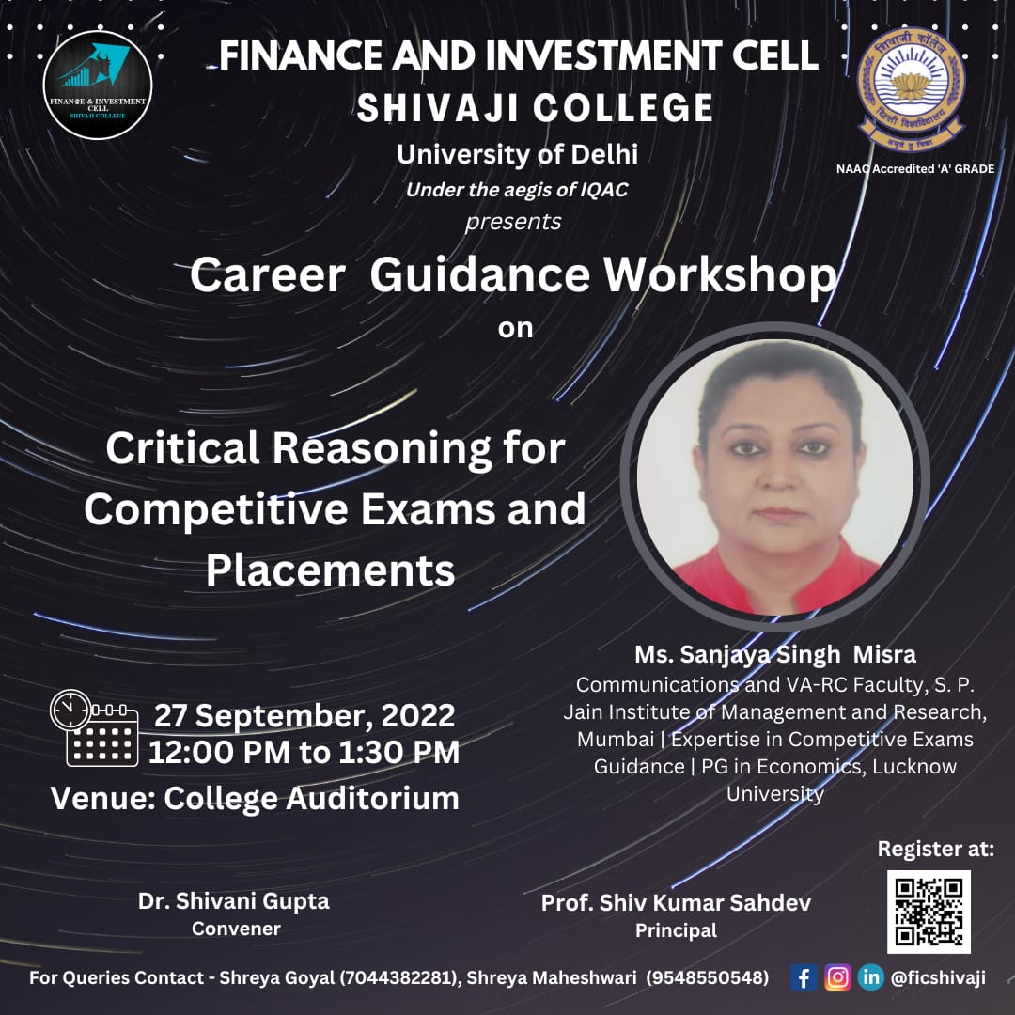
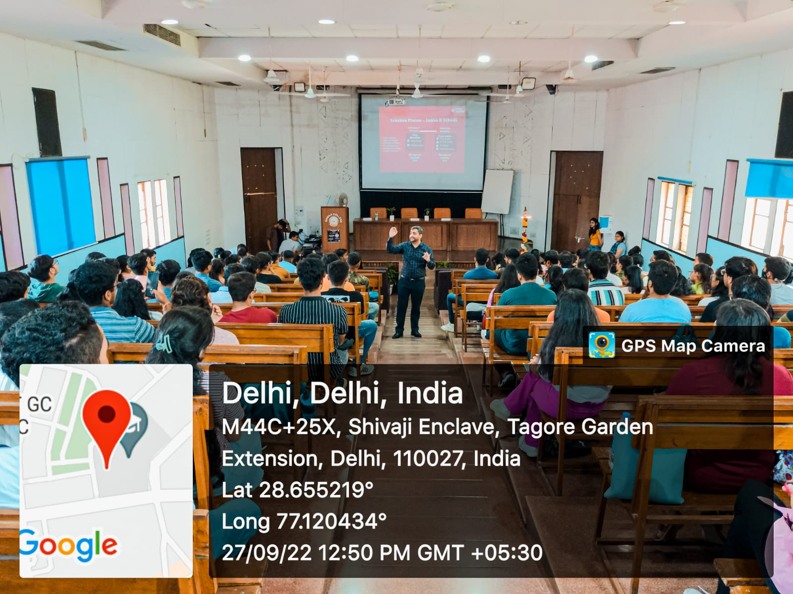
- Report of Annual Festival - “FINANZEN-2023”
Date: 10 April, 2023
The Finance and Investment Society at Shivaji College held their annual fest "FINANZEN 2023" on 10 April, 2023. The fest had three amazing competitions along with an insightful inaugural session to provide students with loads of knowledge along with some competitive spirit.
FINANZEN 2023 was kicked start with an insightful Seminar on Insurance Growth in India. Mr. Shivam Ahuja, Founder and CEO of SkillCircle, TEdx and Josh Talks speaker. As scheduled, it began at 10.30 a.m. with a warm greeting from the host, followed by the incisive words of the respected principal Prof. Shiv Kumar Sahdev. The speaker began with an introduction to himself, including his personal path, in which he highlighted the reality that each individual is unique. Followed by this, he discussed the state of the e-Commerce industry and the growth of digital marketing. He summed up his session by underlining the fact that the e-commerce sector is growing day by day. Following that, he discussed asking questions. He responded to the vast majority of the inquiries. It was an informative seminar, and students took a plethora of info away with them.
Following the Seminar , three competitions were held, which comprised quizzes, trading, and problem-solving to put the financial aficionados to the test.

TRADE-O-MANIA
Trade-O-Mania was held on April 10. In the first round the participants were asked financial and investment questions to test their knowledge and skills . In the final round, each participant received prospectuses of 10 companies and up to Rs 10,00,000 of virtual cash to invest in those companies. The participant with the highest portfolio value was declared the winner at the end of the game. The event was a success with more than 200 registrations.
BIDS AND BULLIONS
Bids and Bullions was held on April 10 at noon. In Round 1, participants were tasked with bidding on enticing deals and offers from renowned companies and brands as representatives of a credit card company. This stirring bidding round tested their nerves, strategic thinking, game theory, and intuition. During the final round, real-time news and rumors of each security were flashed to the teams, and they engaged in decentralized trading in a trading ring based on their analysis of this information. This event was a success and gathered over 120 registrations.
TRADE VENTURE
The first round of the competition, called Finbola, tested the knowledge of the participants in the commerce world. Each team was provided with Tambola Strips that contained answers to questions which they had to identify and complete the Tambola game.
In the second round, Deal or No Deal, the marketing techniques and strategies of the participants were tested. They had to trade commodities within a given budget all around the campus. The one with the best trade won the competition.
To summarize, the annual event was a success, and both the attendees and the hosts had great experience.
